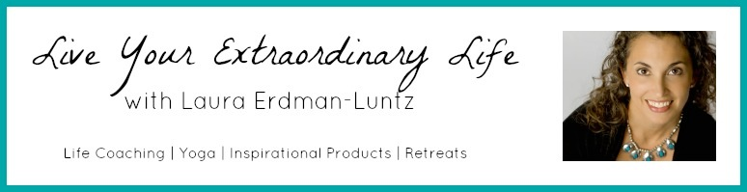

Easy Steps for Creating Changes in Your Life

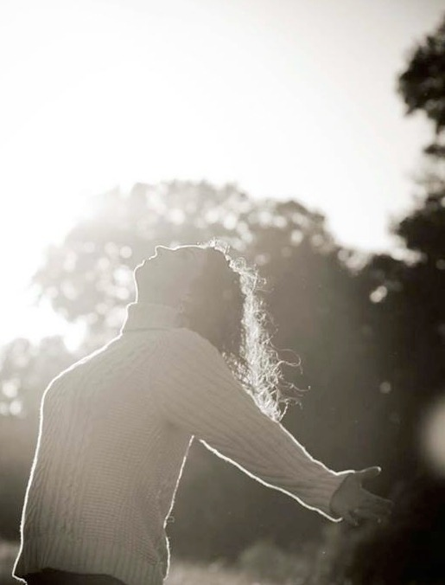

with Laura Erdman-Luntz
Life Coach, Yoga Educator, Author

“We are always getting ready to live but never living.”
- Ralph Waldo Emerson

It is time to start living!
Congratulations on taking this important step in your life.
I look forward to sharing this journey with you.

Thank you for joining me!

www.LauraErdmanLuntz.com
Laura@muselan.com
I am Ready to a Make Change in my Life

Step 1: What, Why, and When

What do I want?
What is it I want to create?
{Make sure your desire is in the positive. Move toward what you want, not away from what you don’t want. Need more support: http://bit.ly/161SKHC}

So, now, what is in my heart of hearts?
{For brownie points, listen to the visualization on the blog post above to dig deeper and discover what you really want.}

Why do I want what I want?

Why is the change important to me? How will my life be different as a result of making this change?
{By the way, you may find you can’t think of a positive reason. Then you know it is time to change your goals! Need more support: http://bit.ly/1dV7X2V}

When do I want what I want?

When do I want to be done creating what I want to create:
{Need a little support: http://bit.ly/13orLoE}

Can I make the time line a bit shorter?

Yep, I am ready to take a bit of a leap here...
I intend to have my intention completed by....

Step 2: Feel You Deserve It

I deserve what I want!
{You need to build a little umph behind your desire so you can create your change! Need a little support: http://bit.ly/18KYYJz}
Also, Yoga for Personal Strength: http://bit.ly/15NZGUq
Breath for Building Personal Strength: http://bit.ly/1aYv4Y9

Step 3: You Need to Take Action

What do I need to do?
{And then you need to get started! Make sure your first step is so tiny and easy, you easily accomplish it! Need a little support: http://bit.ly/1aAeLlk}

Step 4: Feel Good

What will I do to Feel Good?
{Feeling good helps you overcome the inertia of the status quo AND keeps you energized. Change takes energy! Need a little support: http://bit.ly/1d8y5n4
Also, my Feel Good Practice I share with you: http://bit.ly/194D4Cg
AND my Feel Good Moments on the blog: http://lauraerdmanluntz.com/index.php/category/feel-good-moment/}

~ My Just Feel Good List ~
Quickies:
Some Time:

Lots of Time:
My Super Quickie List:
Step 5: Stay Inspired

What if it was 5 years from now and nothing had changed?
{Sometimes you need a little somethin’ somethin’ to keep yourself going. How about visualizing your life five years from now and nothing has changed? Need a little support: http://bit.ly/1bmYQpO}

When people work with me, their lives change.
Are you ready?
Here’s your next step...

Email me. Let’s discuss your options: Laura@muselan.com

Life Coaching: I work privately and in groups. I usually have a space or two open up in my private practice each month, check for availability. I also begin new coaching groups regularly. If you have a group of 3-5 people with which you would like me to work, contact me directly to check availability.

Five Steps (Plus One) for Living Your Extraordinary Life: I teach this course in a couple formats:
- Privately: We can do it one-on-one to move powerfully forward.
- Teleclasses: Join me from anywhere via teleclass. I teach the course to groups on a regular basis.
- Private Groups: Have a ready-made group you would like me to inspire? Contact me to make arrangements.

Ready? Check the website: www.LauraErdmanLuntz.com,
and click on “Life Coaching”
Other Inspirational Opportunities with Laura:

Monday Morning Musings: Need some inspiration? Register for this FREE eNewsletter and receive a dose each Monday morning. This eNewsletter will give you a shot of inspiration through a thought that calls you to think more broadly, outside your box. You also receive a link to a “Feel Good Moment”, something that takes no more than 5 minutes to watch or read that helps you feel better! Register on her website: www.LauraErdmanLuntz.com

About Author Laura Erdman-Luntz, MA, E-RYT(500)
Experienced Yoga Educator, inspiring Life Coach, author and Business Entrepreneur, Laura Erdman-Luntz, has over 20 years experience in the fitness and wellness industries. She uniquely blends her Life Coaching knowledge and vast experience with Yoga to create programs, classes and workshops that truly do bring mind and body together for positive change, inspiring people to live their most authentic life. She incorporates New Thought ideas into classes and programs on positive living, manifesting and changing subconscious beliefs. Laura has published three books, including: Awaken to Joy, My Inspirational Year, and Yoga Essentials: Muselan’s Guide to the Yoga Poses, co-authored by Jill Barber.

More Praise for Coaching with Laura:

Karen Peterson: “You have shown me that I can live the life I want – one based on my values and dreams – without fear. I feel more confident in everything I do. Everyday is a joy because I am finally living my purpose. Without your guidance and insights, I would never have gotten this far, this fast. Thank you from the bottom of my heart.”

Dr. Susan Quigley: “I have so much gratitude for finding Laura and having the opportunity to work with such an inspiring Muse! I highly recommend her workbook, calendar, yoga classes, and retreats! You will find a freedom you did not know was possible in your life!"

